NYLET ORDER FORM www.nylet.co.uk |  |  | Nylet  the longest established model sailmakers in the world, 92 years, since 1932. Mail order since 1958.
Nylet
Salisbury, UK.
phones: 01722 239251 (Int. +44 1722 239251 )
07474 939535 email frank.nylet@outlook.com
Your name (please print)
Full address (please print)

Post town/city

Postcode/Zip
Email this to us and we’ll return to you with the post/cge cost and with the amount to pay.
Country
Tel no/s |  | Your email -
Date. / /2024 | Tell us how you wish to pay – VISA/Mastercard; electronic bank transfer; PayPal (delete those not applicable). Note: Cheques currently not accepted.
Paying via BACS, please ask for our account details. | If paying via card please phone details to us, don’t email/write numbers.  Listing part numbers numerically will greatly assist.
pt no. | DESCRIPTION (listing fittings in numerical order will assist us, thank you). | qty | price each | £ | p | Nylet use only
2024 Q2  nylet |  |  | p&p
PayPal
fee
Grand total £
Thank you for your order. This order form is primary intended for those wishing to pay via cheque. You may prefer to phone or email your order if using a card/PayPal/bank transfer. Unsure of the postage/carriage then leave it blank if you are paying by PayPal or card and we will advise the total (additional charge made if paying by PayPal or card). If paying by cheque or Postal Order please make payable to “F.Parsons” (NOT Nylet). *NOTE: we must have your phone number. Full postage rates can be found on http://www.nylet.co.uk/order.pdf

Thank you for your order. You may prefer to phone or email your order if only ordering a couple of items. Unsure of the postage/carriage then leave it blank. If you are paying by PayPal or card we will advise the total (handling charge made if paying by PayPal).
*NOTE: we must have your phone number & email. Full postage rates can be found on http://www.nylet.co.uk/order.pdf If unsure of postage we can advise most economical route, or for speed then perhaps you might like your order despatched via Special Delivery post at extra cost? We will advise post & carriage rates/charges and availability of service.
pt no. | (CONTINUATION SHEET)  Description | qty | price each | £ | p | Nylet use only
We suggest you keep a copy of your order. |  |  | p&p
 |  |  | total £

Any other information we should know, a diagram, or a sail sketch, then please note it here.

Nylet use only.
Date received / /24
Paid - PayPal/ card/BACS/ other -
fully paid £ _____________________
o/s amount £ __________________
credit £ _________
delv 1. ____________________
delv 2 ________________________
completed on ___________
wt. gr. desp 1st/signed for/ LL/SP/MP/AIR MAIL/
SP Delv/DPD/FedEx/EVRI/other. No. pcls 1 2 3 4
Nylet
92
years
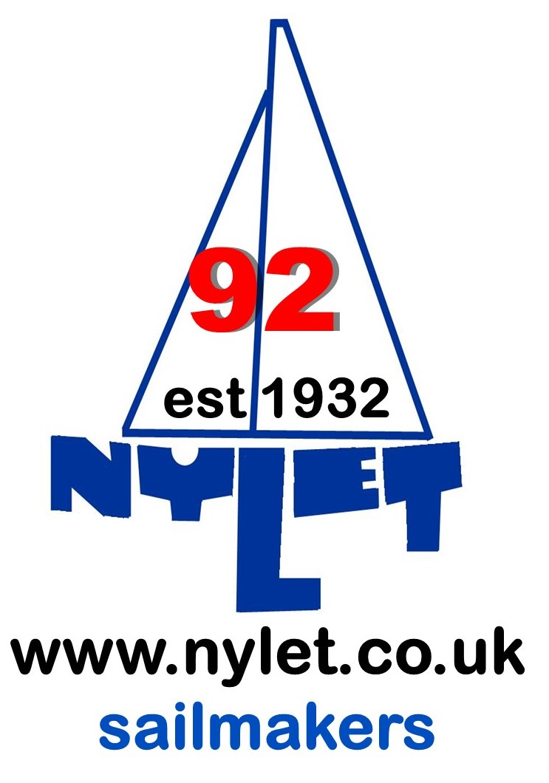
nylet

